App Architecture Layout

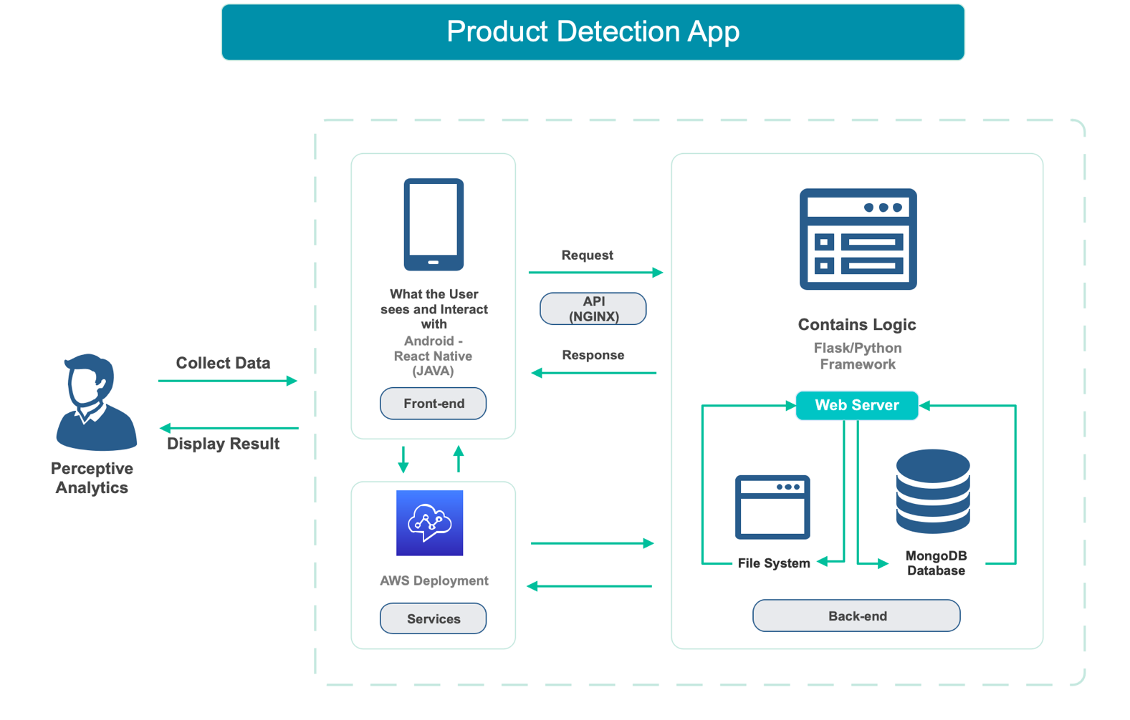

Frontend:

React Native suitable for the job since we are planning to build cross-platform app that has a scalable scope, and with React’s community support and extensive documentation we can easily work upon the modifying code base.

Backend:

Flask suitable for the job since initially we are developing on a small platform, which must have coding flexibility, and require better control over database. Flask is suitable for rapid prototypes.

Database and Web Servers:

MongoDB for ease in interaction with React, and Web Servers as NGINX to promote quicker concurrency in API, and other data transfer across the network.